Travis Moore

PSY201: Section B — Fall 2016

Professor: Vanessa Hemovich

**­**

Homework Assignment #7  
Creativity & Logical Thinking

Consider a video game that you have either had personal experience playing, or are otherwise very familiar with. You may choose to draw from other experiences beyond games (e.g., film/TV, books, social media, etc.)

1. Describe an example of creative thinking that utilize each of the following “6 Thinking Hats”

1a. White Hat:

For the following “6 Thinking Hats” examples, I’ll be utilizing the thought process of my game team as we gather up the strength we need to turn in our project, “Planetary Pest Squad”. Using white hat thinking, which focuses on the available information and data, we took a good look at the rubric and our game to see where we stand and what needed to be done with the game. Using our experience in making games so far we then extrapolated how much we think we can get done in the time we have left.

1b. Red Hat

We have quite a lot of passionate people on our team who feel, despite the rubric not needing certain things, that our game cannot not be complete until there are certain features in the game that would make the game just feel good. These people feel that the gut reaction and emotion response of our game would not resonate well without these key features, despite not necessarily needing these features to pass our GAM400 class.

1c. Black Hat:

One person in particular for our group always focuses on the bad side to every problem or decision that we are contemplating for our game project. We can always count on them to bring up counterpoints to why a new idea will never work and will ruin our game. For example, they thought focusing on making a game that was both cooperative and competitive at the same time would just be the worst thing in the world to do. They made sure to point out every reason why they thought this would never work and that we’d be dumb to try it.

1d. Yellow Hat

Thankfully, there are a lot of “yellow hat thinkers” in the group who focus on the potential for the positive benefits that come with new ideas. Due to this positive thinking our game has gone forward with the idea that we can make a team based game with some competitive elements for it. This thinking has really reaped us a lot of rewards and positive playtesting feedback.

1e. Green Hat:

The artist on our team is definitely the most “green hat thinker” we have in our group. It is because of his creativity that we’ve made several design decisions around the art and animations he has created for our game. It was his idea to have our Planetary Pest Squad members transform into space ships at will, allowing them to travel from planet to planet. Rachel Rutherford especially loved this idea when we presented our game for the first time.

1f. Blue Hat

Our team’s producer is the most “blue hat thinker” of our team. It is his responsibility to keep us on schedule and approach the production of our game in a very controlled manner. We use Trello to assign tasks and routinely update our list of action items to make sure we are going to be able to finish our game on time.

2. In your opinion, which form of creative thinking from the **“4 C Model” of Creativity** is most utilized in game design? Why?

While most games might be born of “Pro-c” or even “Big-c” forms of creative thinking, I believe that “Little-c” is probably the most utilized creative thinking in game design. “Little-c” involves everyday problem solving, which is essential to the process of creating video games. Ideas for great video games take a lot of creativity, but the ability to do everything needed to make that idea come to life takes a lot of people utilizing everyday problem solving to actually make the game a reality.

3. Generate 2-3 predictions about the future of **artificial intelligence (AI)** and what role cognitive psychology may serve regarding the outcome.

I’m of the opinion that artificial intelligence will only come as far as our own knowledge of understanding how we behave and reason. The more we understand exactly how we are able to make decisions and react to problems, emotion, situations, or any stimulus, the better models we can use to create an artificial intelligence that can behave the same. I think artificial intelligence will always be limited in some way, whether through fail-safes or our own limitations for understanding cognition. This is not necessarily a bad thing; as artificial intelligence needs only be as capable as it needs to be depending upon its intended use. The more models we are able to generate from our understanding of cognition; the more tools we have will to create an artificial intelligence that behaves in a more “human-like” way. However, I do not believe that the purpose of artificial intelligence should be to mimic human intelligence. It’s not that I do not see a point for it, but I think artificial intelligence doesn’t need to be perfectly human. As long as we’re in charge of making artificial intelligence the way we want it to be, why limit ourselves to thinking artificial intelligence needs to be this way?

As for predictions about the future of artificial intelligence I think the field for studying and developing artificial intelligence will continue to expand, but will always be a little bit scattered due to everyone having a different goal for what their artificial intelligence is meant to achieve. I do not believe there will be a convergence of artificial intelligence transcending to something more than what we make of it.

4. Follow the instructions below to cognitively create a new object based on a combination of the objects found within the box below:

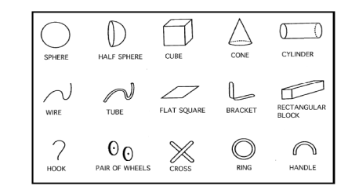

1a. Select up to 3 object parts that are shown pictured to the right (minimum selection is 2).

1b. The size, orientation, and position of the object parts can be adjusted. Wires, hooks, and tubes can be bent.

1c. Draw an image of the new object you have created along with a detailed explanation of its function.

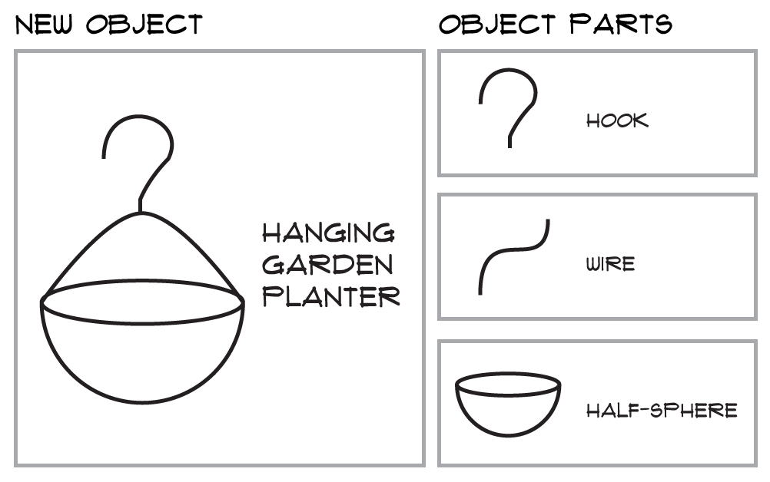

From the hook, wire, and half-sphere I have created a hanging garden planter. The hook and half-sphere are not modified, but the wire is bent and attached to the half-sphere and the hook to create a completely new object. The hanging garden planter can be used to hold a plant that can be hung from a balcony roof hook, much like the planters I use for my hanging succulents at home.